**Lab 06 - Implement Traffic Management**

**Student lab manual.**

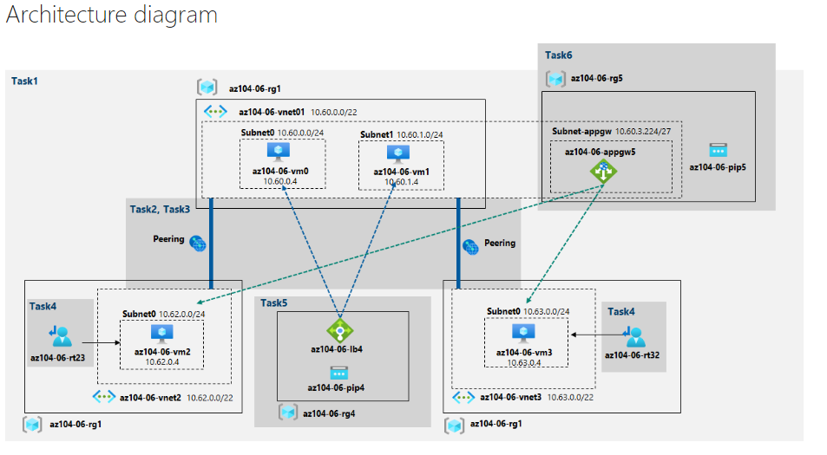

* **Task 1: Provision the lab environment.**
  + 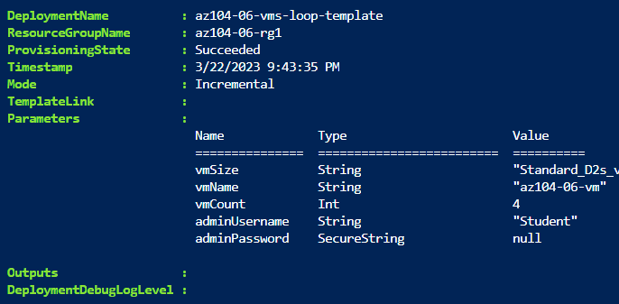Executing the first code, output:
  + Executing the first code, output:

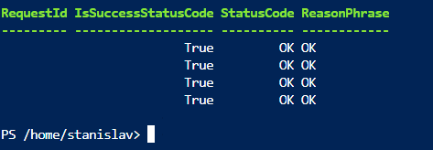

* + Provision the lab environment :

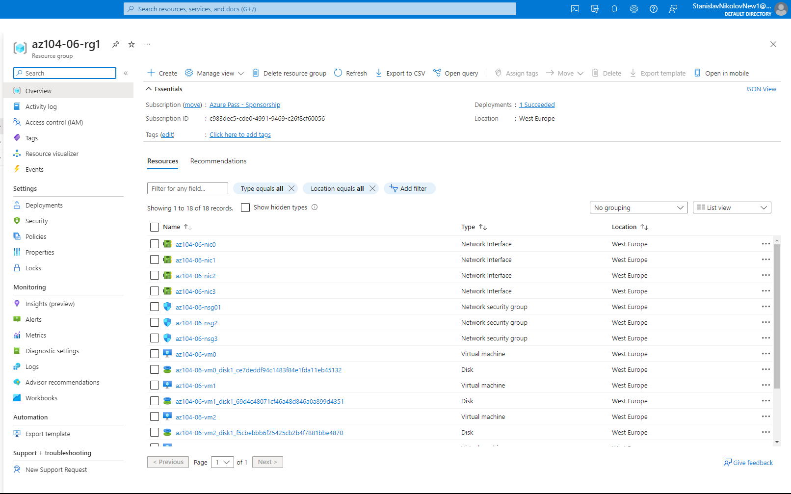

* **Task 2: Configure the hub and spoke network topology.**

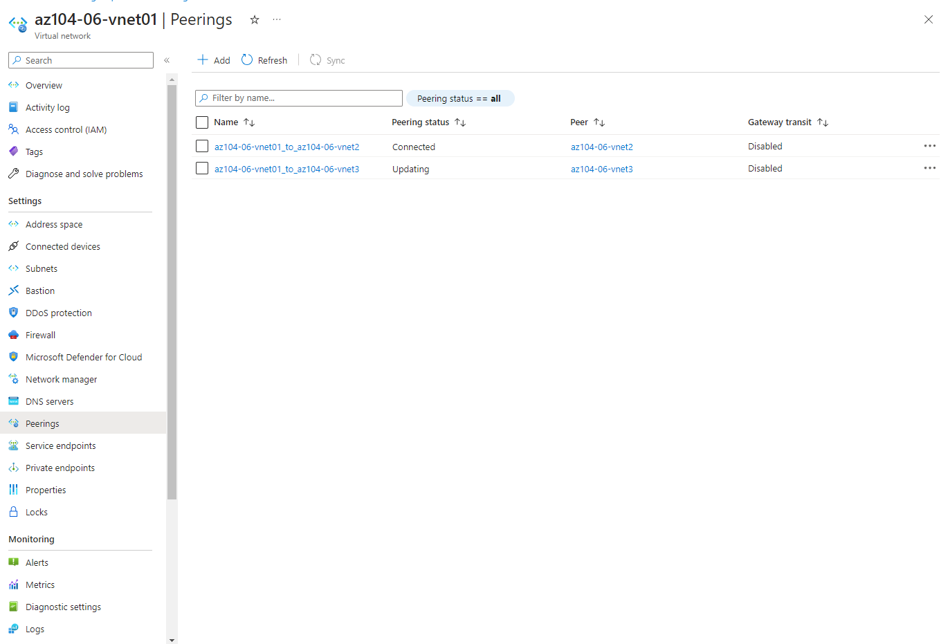

* + This step establishes two local peerings - one from az104-06-vnet01 to az104-06-vnet3 and the other from az104-06-vnet3 to az104-06-vnet01. This completes setting up the hub and spoke topology (with two spoke virtual networks).
* **Task 3: Test transitivity of virtual network peering.**
  + In this task, you will test transitivity of virtual network peering by using Network Watcher.

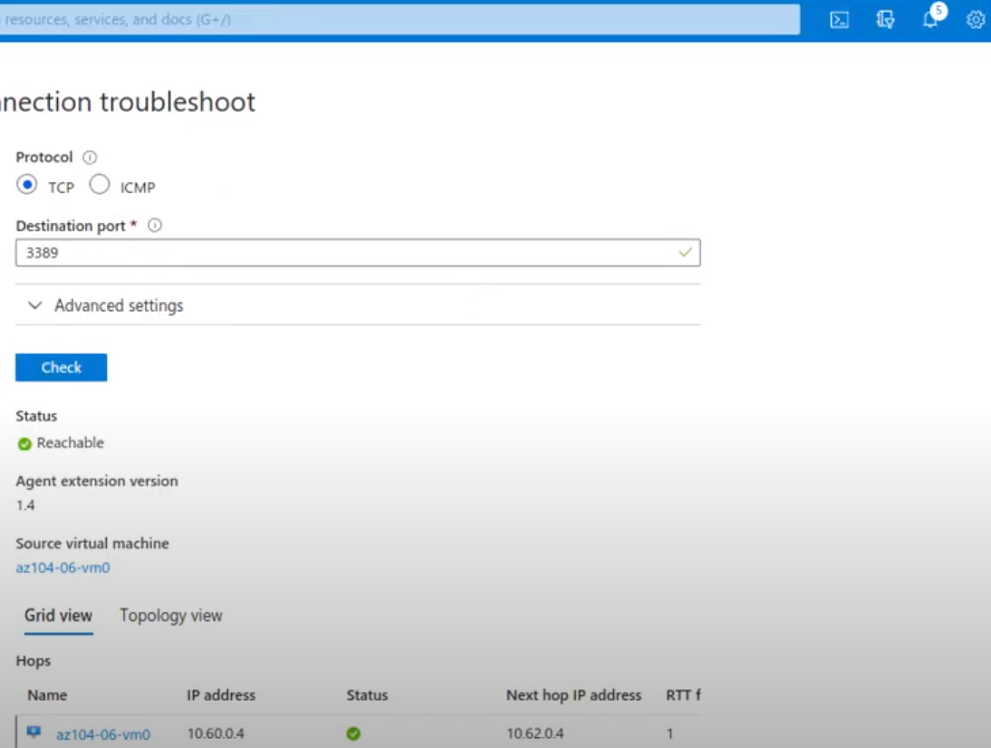

The status is Reachable. This is expected, since the hub virtual network is peered directly with the first spoke virtual network.

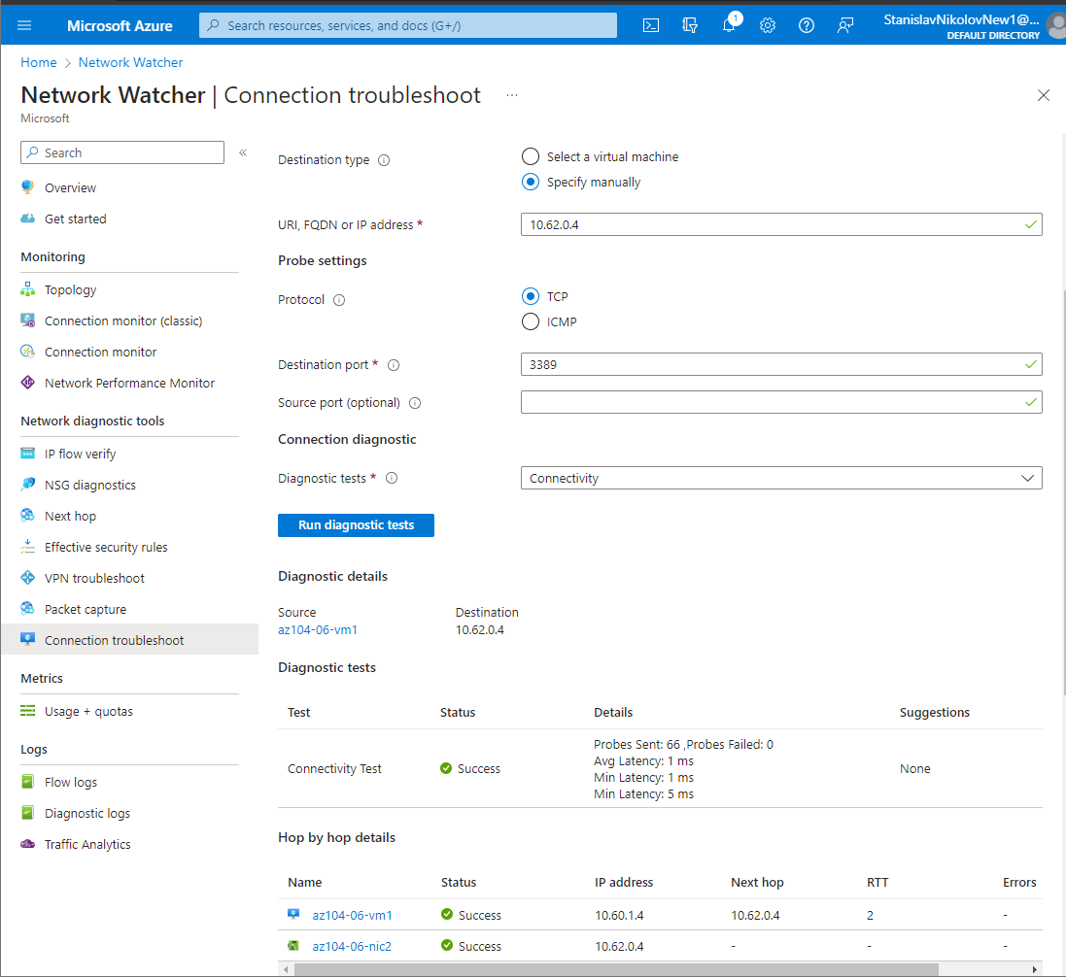

The status is Reachable. This is expected, since the hub virtual network is peered directly with the second spoke virtual network.

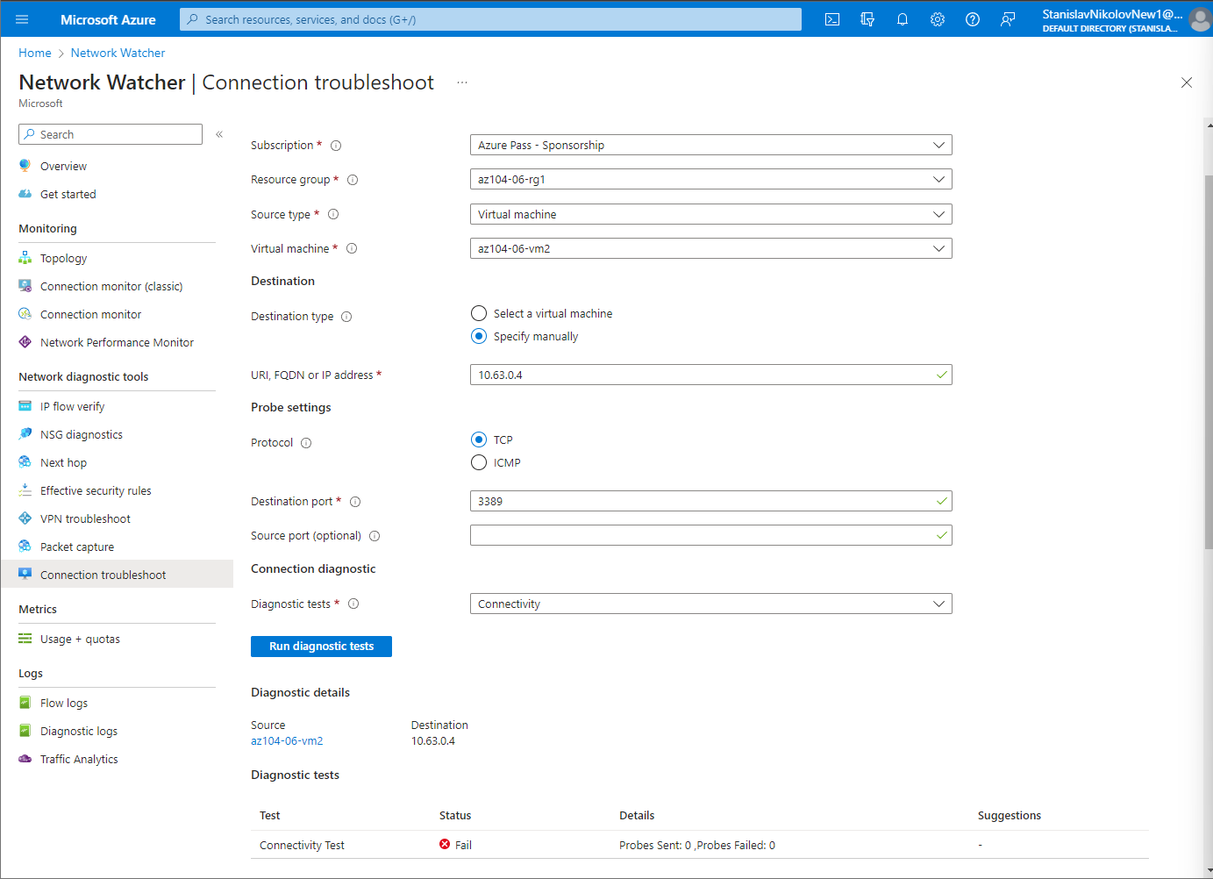

The status is Unreachable. This is expected, since the two spoke virtual networks are not peered with each other (virtual network peering is not transitive).

* **Task 4: Configure routing in the hub and spoke topology.**
  + In this task, you will configure and test routing between the two spoke virtual networks by enabling IP forwarding on the network interface of the **az104-06-vm0** virtual machine, enabling routing within its operating system, and configuring user-defined routes on the spoke virtual network.
  + This setting is required in order for az104-06-vm0 to function as a router, which will route traffic between two spoke virtual networks.
  + And now we should execute some scripts:

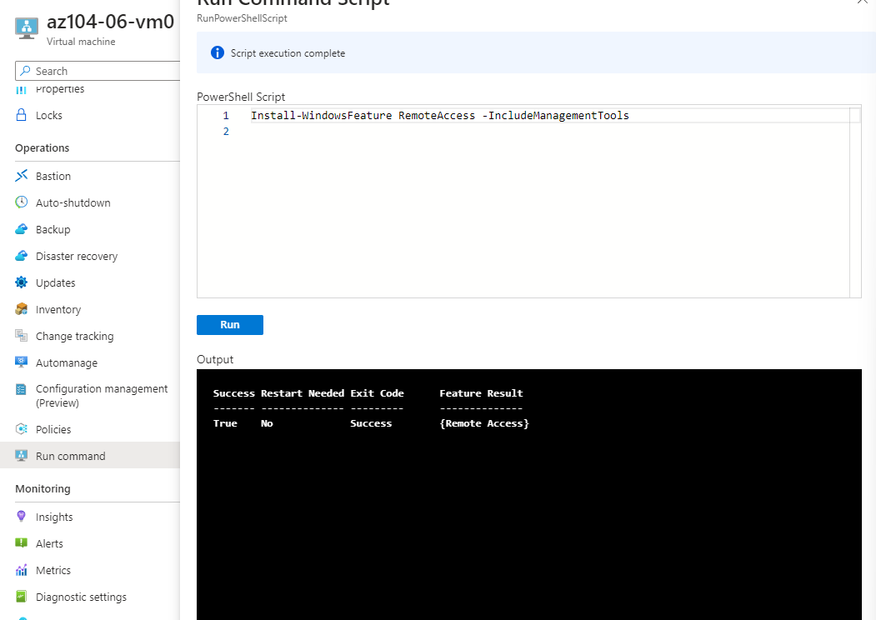

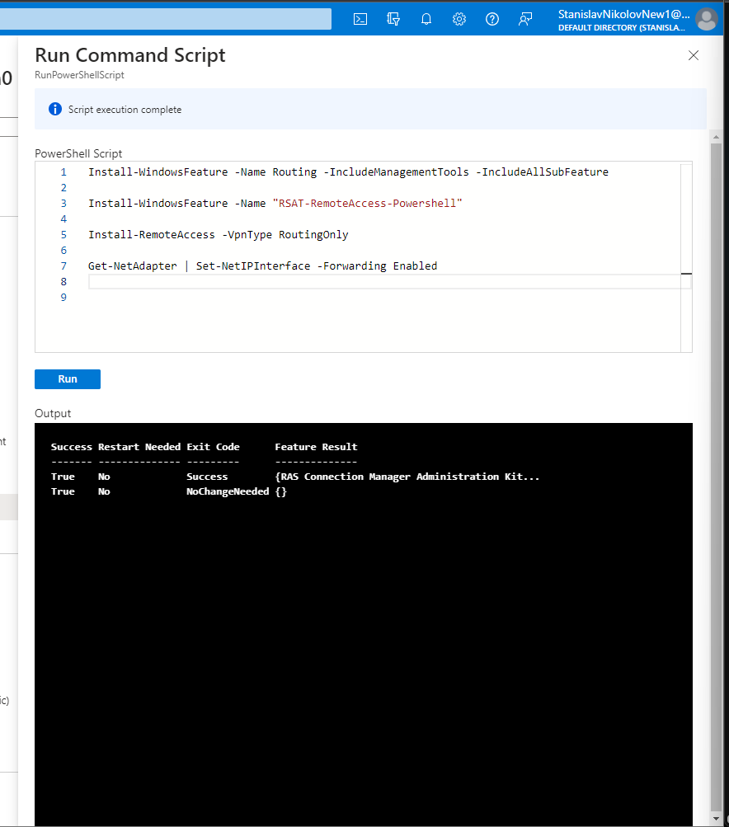

Now we need to create and configure user defined routes on the spoke virtual networks.



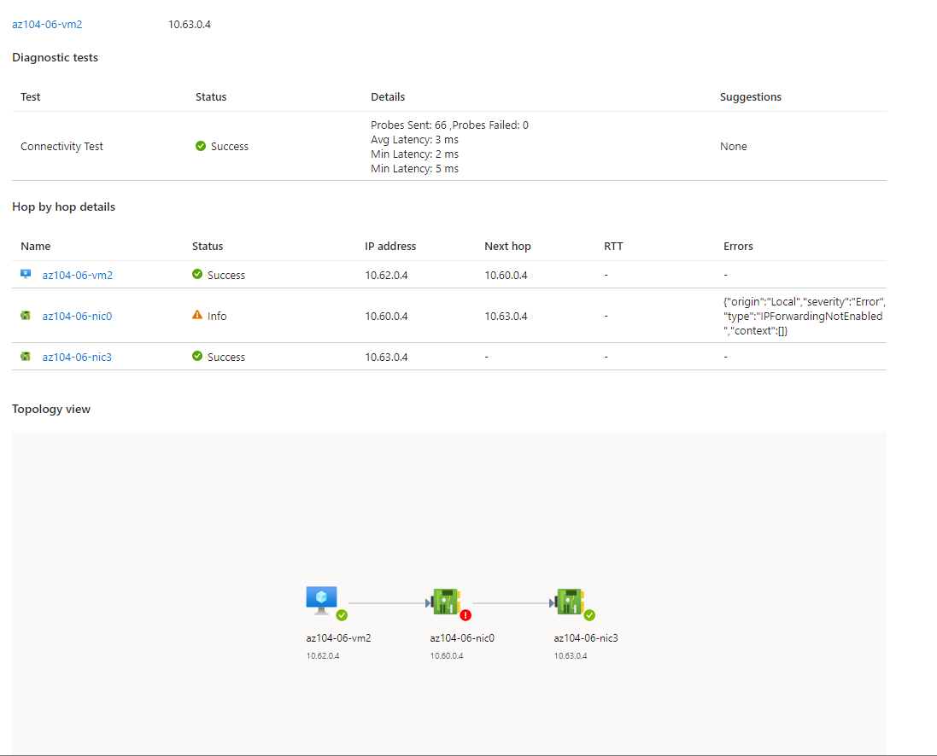

The status is Reachable. This is expected, since the traffic between spoke virtual networks is now routed via the virtual machine located in the hub virtual network, which functions as a router.

* **Task 5: Implement Azure Load Balancer.**
  + In this task, you will implement an Azure Load Balancer in front of the two Azure virtual machines in the hub virtual network.



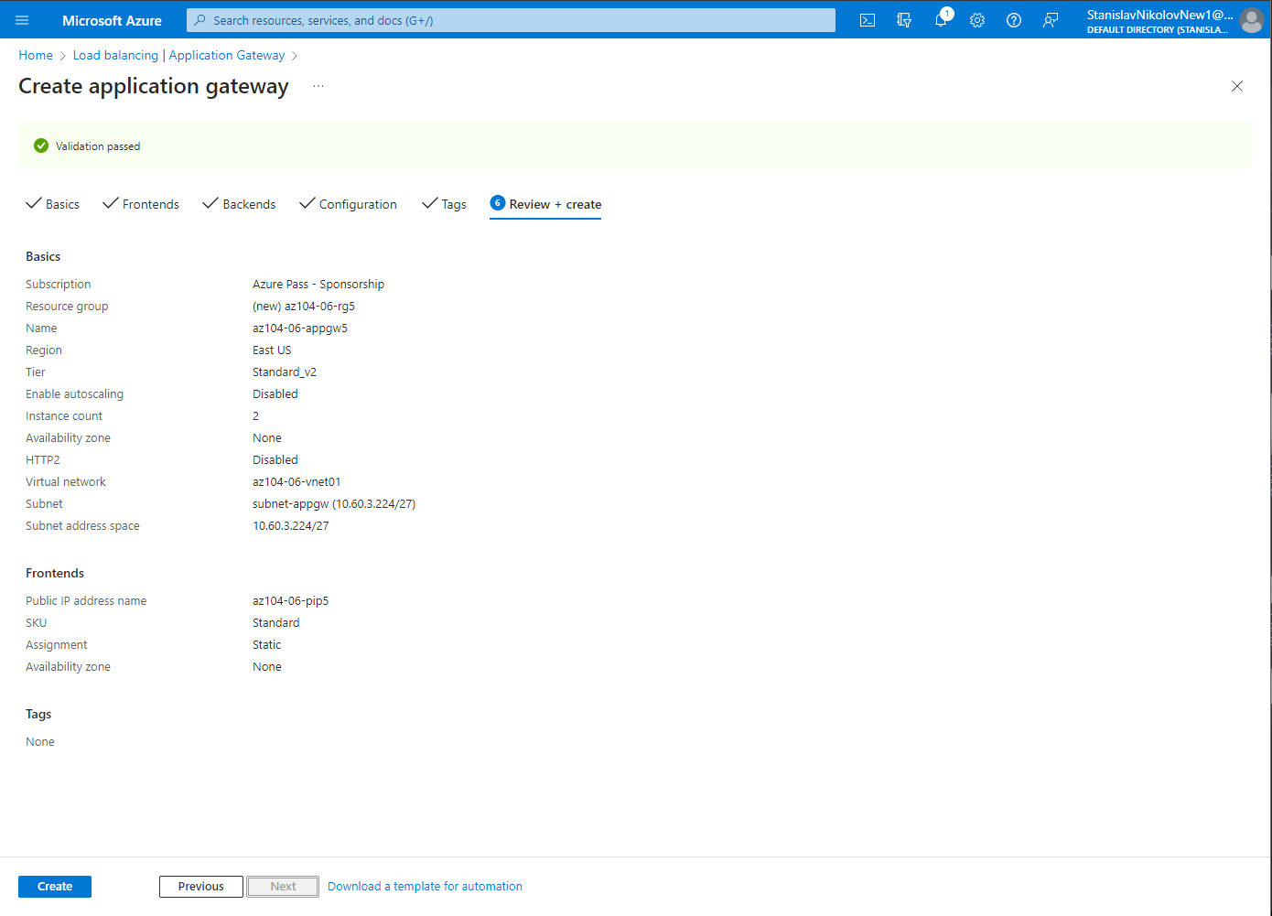

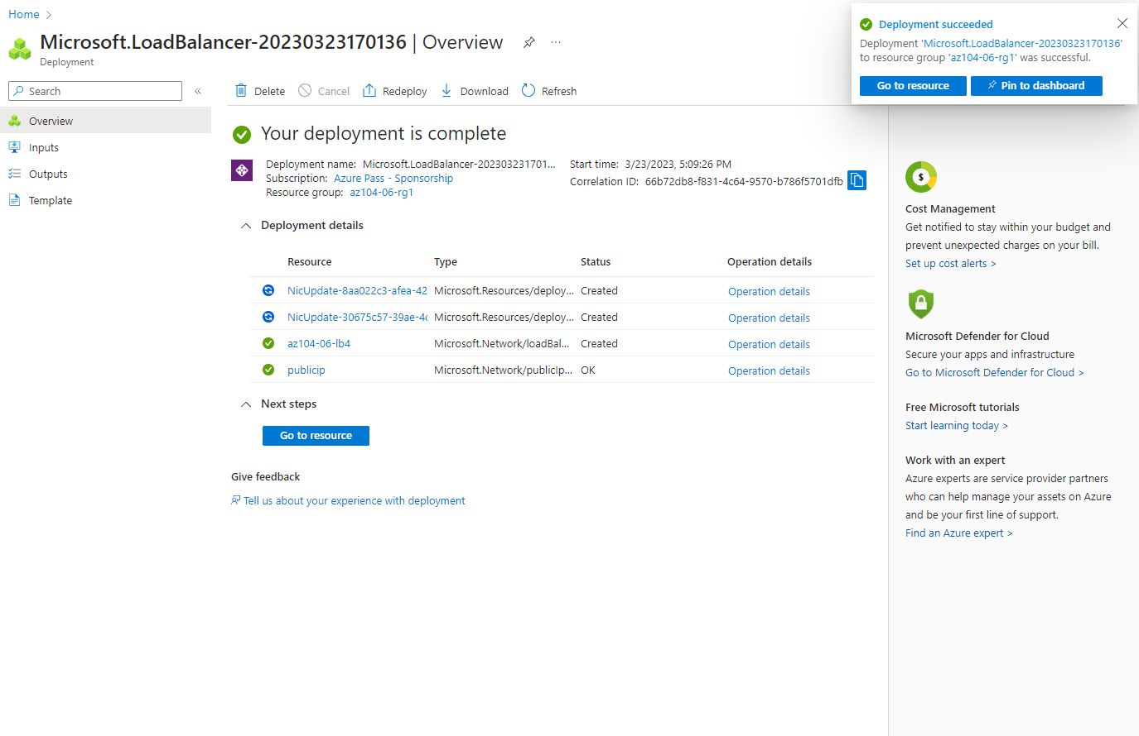

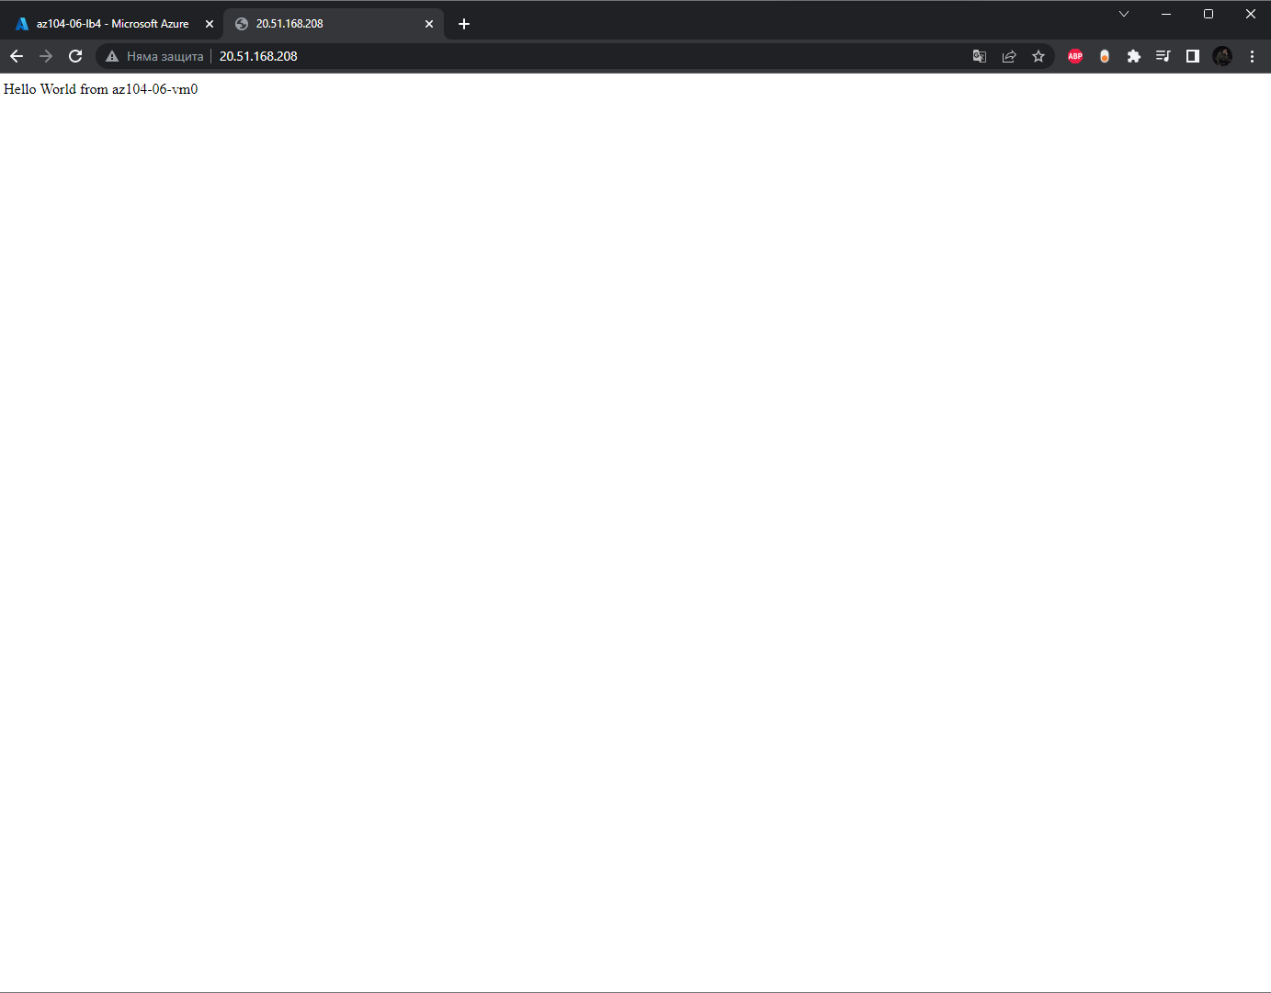

We verify that the browser window displays the message **Hello World from az104-06-vm0.**

* **Task 6: Implement Azure Application Gateway.**

In this task, you will implement an Azure Application Gateway in front of the two Azure virtual machines in the spoke virtual networks.



We verify that the browser window displays the message **Hello World from az104-06-vm2** or **Hello World from az104-06-vm3**.

